
UNIVERSITI TEKNOLOGI MALAYSIA

PROGRAMMING TECHNIQUE II
(SCSJ1023)

SEMESTER 2 2018/2019

GROUP PROJECT
EMERGENCY DEPARTMENT MANAGEMENT SYSTEM

OO PROGRAMMING PROJECT

Khoo Jie Xuan (A18CS0091)
Putera Muhammad Syabil bin Sarianto (A18CS0235)
Pharveish A/L Selvam (A18CS0233)

SECTION 03

Lecturer:
DR. SHAFAATUNNUR HASAN

APRIL 2019

The work in this page has been done by: Pharveish a/l Selvam | Date: 3/5/2019

SECTION A: PROJECT DESCRIPTION

Synopsis:

In this project, we would like to develop a functional interface of the hospital emergency department. It used the concept of object oriented programming which all the details of the department are stored in different objects of different classes which have relationship which related to each other. We have created few files that contains the information of the emergency department and the user will overwrite those files once they perform certain functions in this system.
With this system, the users, who are the staff of the hospital would be able to check which ambulances are available and choose the ambulance by their number plate to be dispatched. To do so, after running the program, there will be a main menu show up with the login in time of the user. The user hits character ‘1’. By entering character ‘2’, users would be able to record for their ambulance operation. Only the ambulance driver would be able to use this function. They only can use it if they are back to the hospital. They are required to key in the number plate of their current ambulance in order for the status of the ambulance to be available for usage. By entering character ‘3’, the user (staff) would be able to view patient information. By entering character ‘4’, user would be able to add in more patients together with their information. This would then update the list of patient information. By entering character ‘5’, the user would be able to view staff information. User would be able to exit the program by entering ‘6’ and all the changes the user made will be remain and store into a file. Thus, the user will get the latest details if he/she login to the system again.

Objective:

The main objective of this project is to provide a functional interface of the hospital emergency department for the hospital staff to have a clear view of their current system of ambulances, patients and staff. The user would be able to check and dispatch ambulance, whereby they would get to see which ambulances are available and choose which one to dispatch. Ambulance drivers can use the program to record ambulance operation whereby which ambulance is returning to the hospital. Staff would get to view and add patient and patient information to the system. Last but not least, users would be able to view staff information. A final function is also included to exit the program.

Tools:
Dev C++

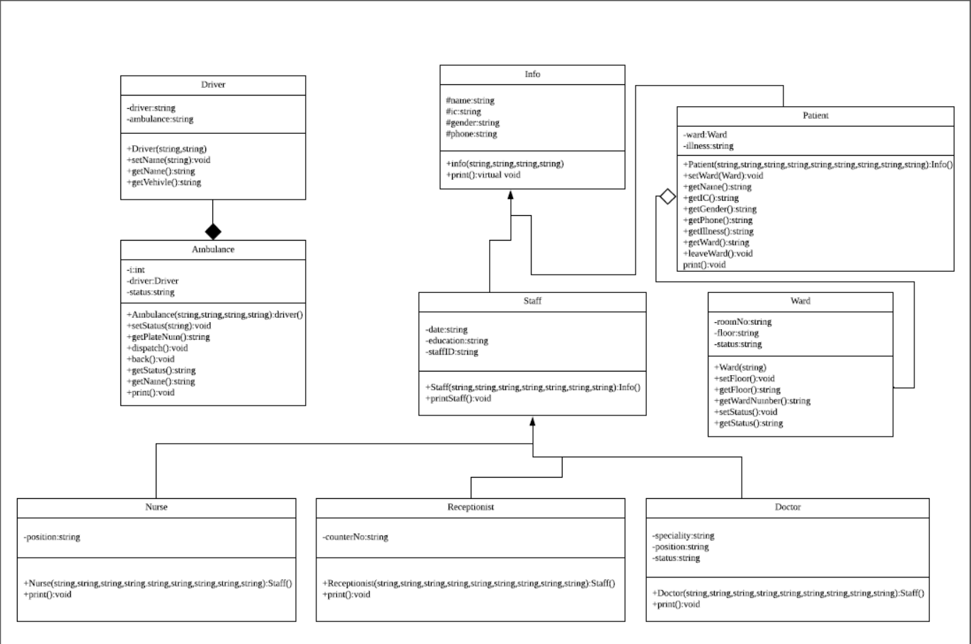

The UML class diagram of the emergency department management system

The work in this page has been done by: Putera Muhammad Syabil bin Sarianto | Date: 3/5/2019

SECTION B: SCREEN DESIGN

Main Screen:

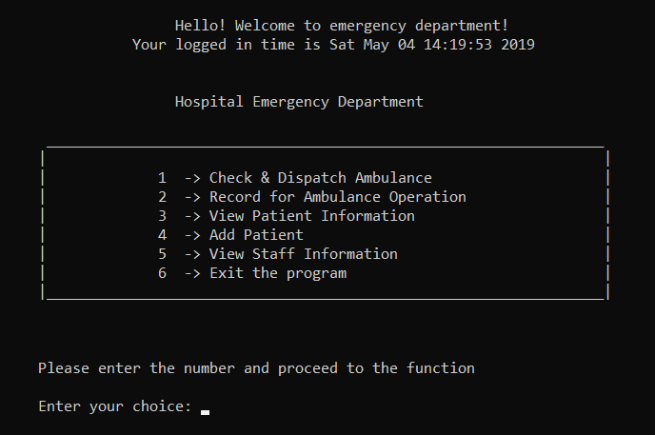
Figure 1

Figure 1, shows the the main screen of the program or the main menu of the program.

Screen 1:
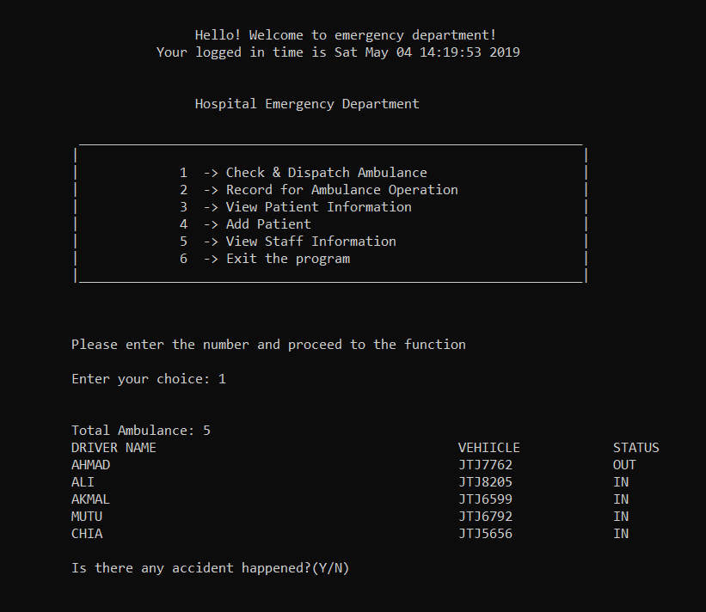

Figure 2
Figure 2 shows the user choose the first option and the program will display a list of ambulance. It will also show the number plate of the vehicle and their status. Whether the ambulance is available or no. And then the program asks for the user to enter an input if there’s any accident happen or no.
Screen 2:
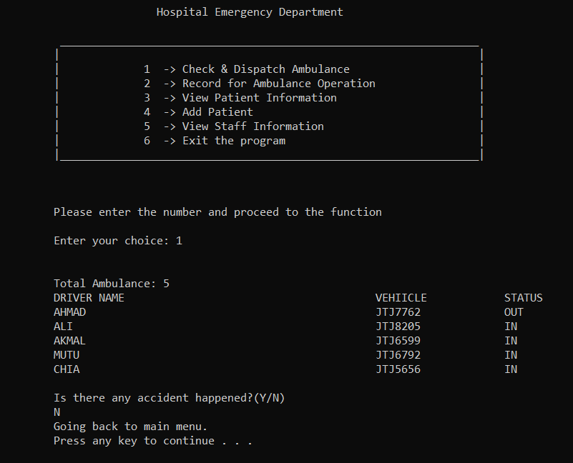
Figure 3
If there’s no accident and the user entered N, the program will asked for the user to enter any key and it will go back to the main menu. As shown in Figure 3.
Screen 3:
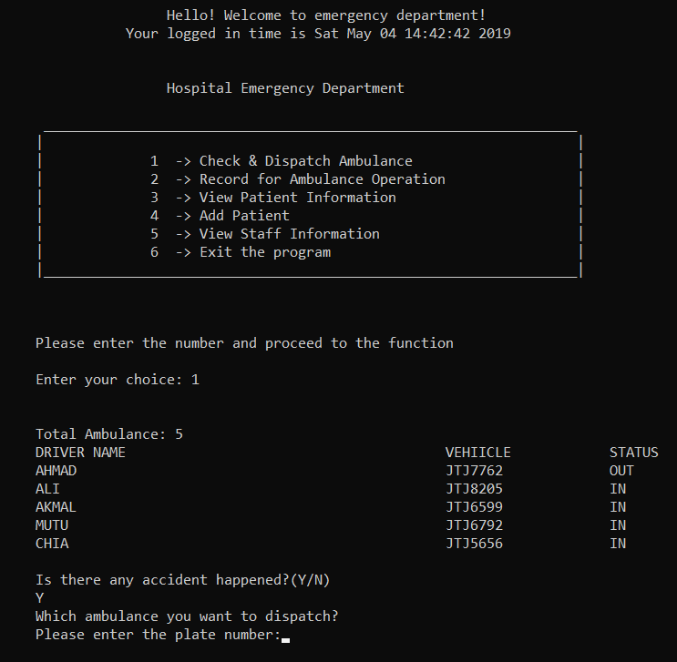
Figure 4
If there’s an accident and the user entered Y, the program will ask the number plate of the vehicle to dispatch it out. As shown in Figure 4.

Screen 4:
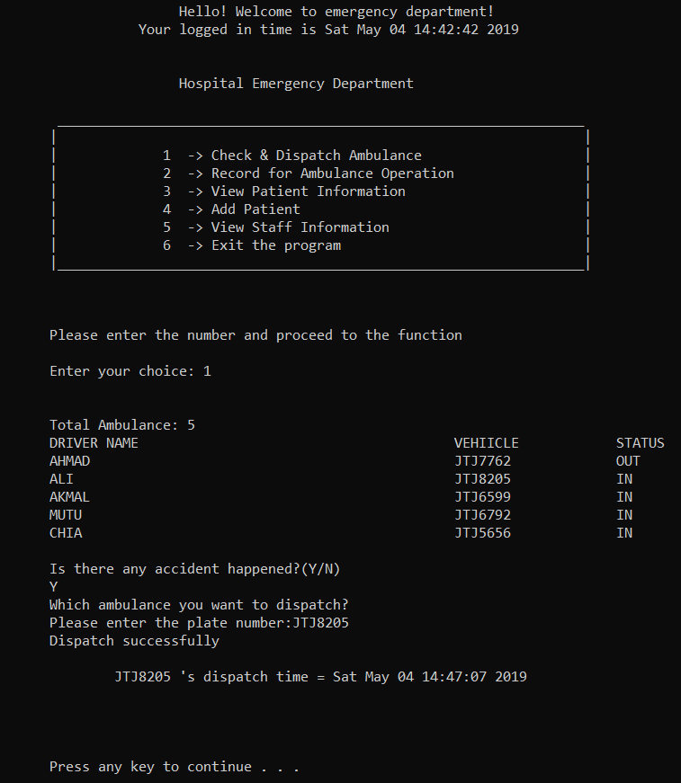
Figure 5
When the user entered the plate number of the vehicle, the vehicle will be dispatch and the program will shows the output same as Figure 5. For example, Figure 5 shows that vehicle JTJ8205 were entered by the user to be dispatched out. It will also show the date and the time of the departure. Next, the program will ask the user to enter any key to continue back to main menu.

Screen 5:
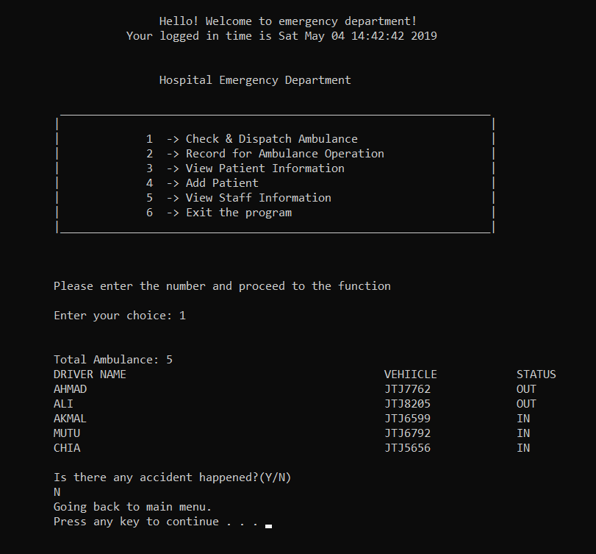
Figure 6
Figure 6 shows the status of the vehicle after vehicle JTJ8205 dispatched out. And then the user entered N and the program proceed back to main menu.
Screen 6:
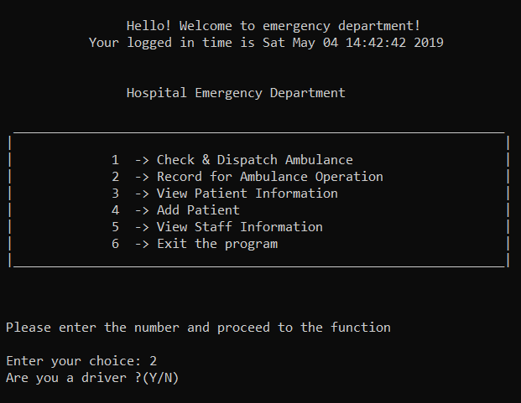
Figure 7
Figure 7 shows the user enter 2 and it will show the record for Ambulance Operation. And the program will ask the user whether the user is an ambulance driver or no.

Screen 7:
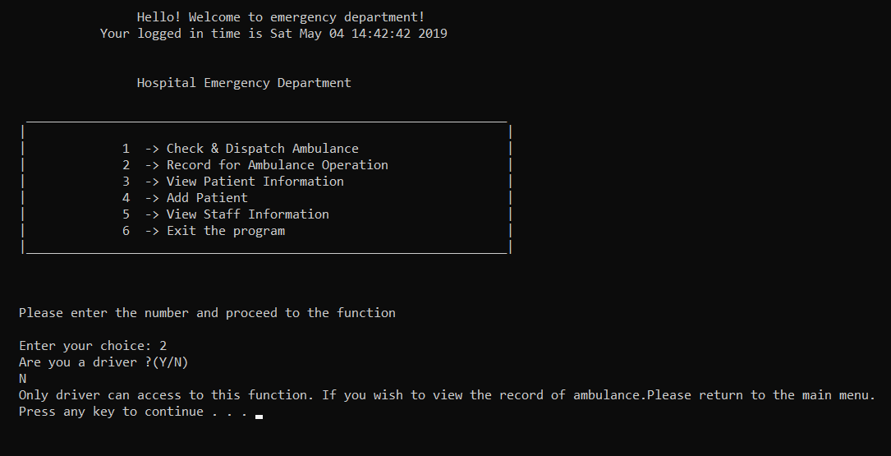
Figure 8
If the user enter N, the program will produce output like Figure 8 and the user need to enter any key to proceed back to main menu.
Screen 8:
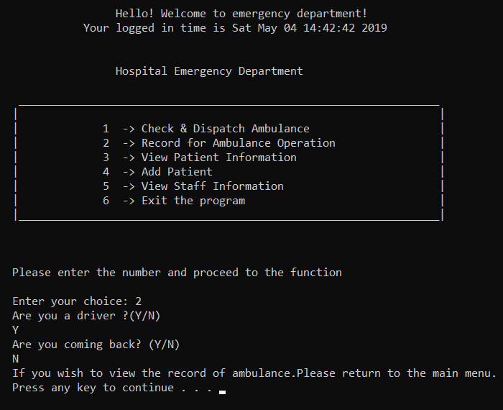
Figure 9
If the user is a driver, the program will ask whether the user is coming back or no. If the user is not coming back and entered N. The program will go back to main menu. As shown in figure 9.

Screen 9:
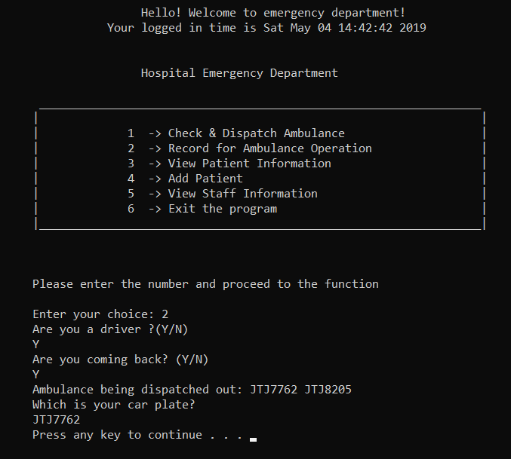
Figure 10
Figure 10 shows that the user is the driver and the user will be coming back. Thus the program will show the list of plate number and the user need to enter the plate number. For example, in Figure 10 JTJ7762 is entered to the program.
Screen 10:
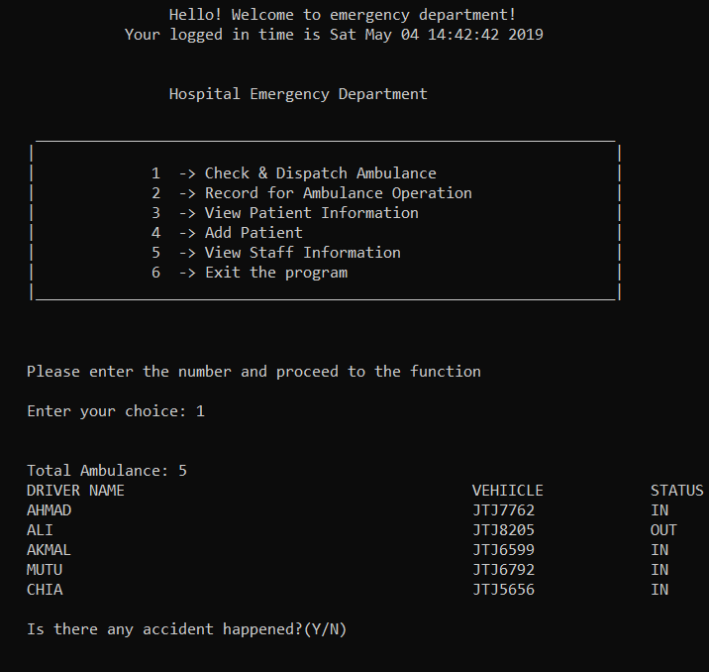
Figure 11
Figure 11 shows that the user can check the availability of the vehicle back in first choice of the program. Vehicle with plate number JTJ7762’s status is set as IN. Therefore, the vehicle has come back to the hospital after the action from Figure 10.
Screen 11:
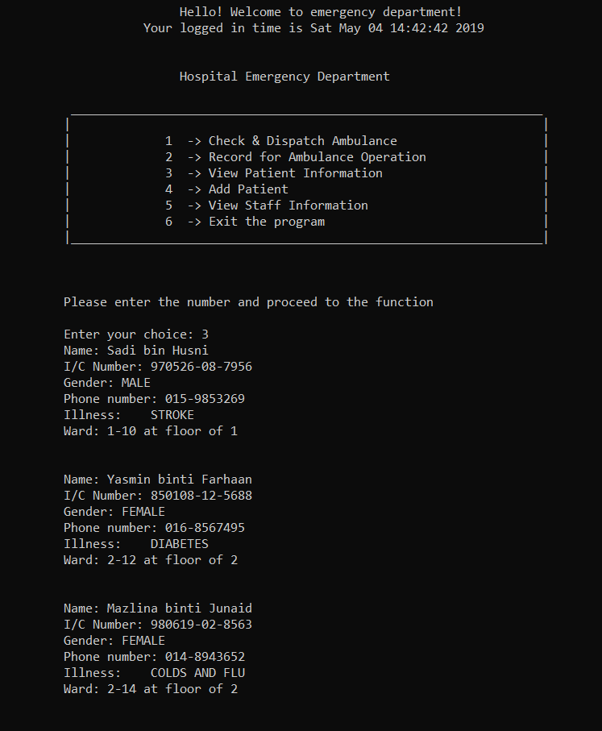
Figure 12
The third choice of the program allow the user to view list of patient information consist of their name, identity card number, gender, contact number, patient’s illness and patient’s ward.
Screen 12:
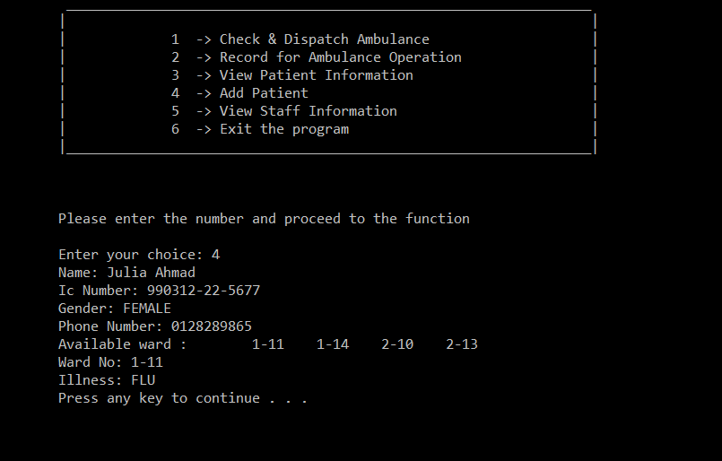
Figure 13
Figure 13 show the fourth choice of the program. It let the user add to patient to the program. In figure 13, Julia’s information is entered by the user. After that, the program proceed to main menu.
Screen 13:
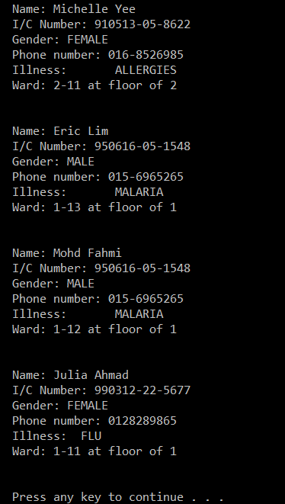
Figure 14
Patient information will be updated after adding new patient to the program. In Figure 14, Julia’s information can be seen by the user in second choice of program in main menu.

Screen 14:
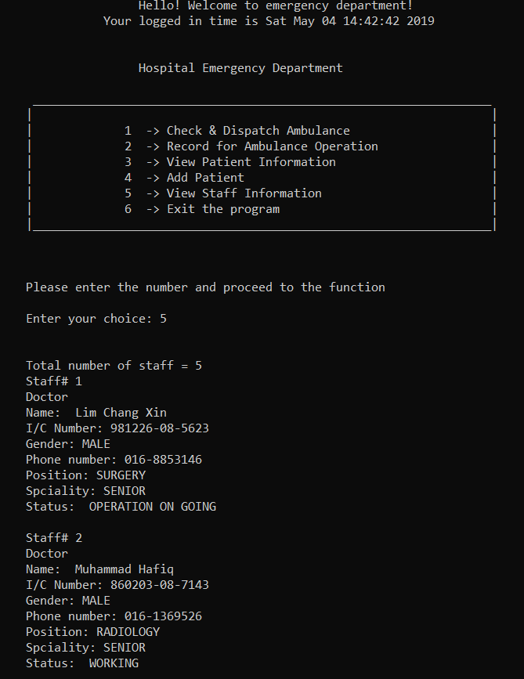
Figure 15
The fifth choice will print out staff information such as name, identity card, gender, contact number, position, speciality, and status.

Screen 15:
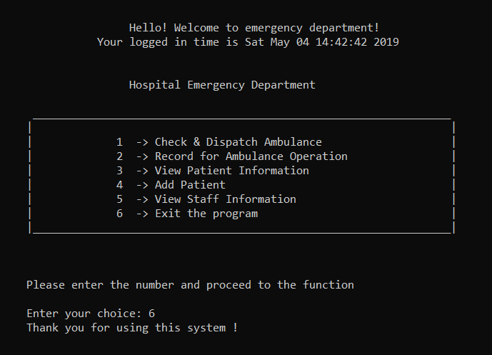
Figure 16
The sixth choice is to quit the program. A thank you message will print out as shown in Figure 16.
Video of program’s URL: https://youtu.be/FcS8CGtQvdg

The work in this page has been done by: Khoo Jie Xuan | Date: 3/5/2019

SECTION C: FLOW CHART
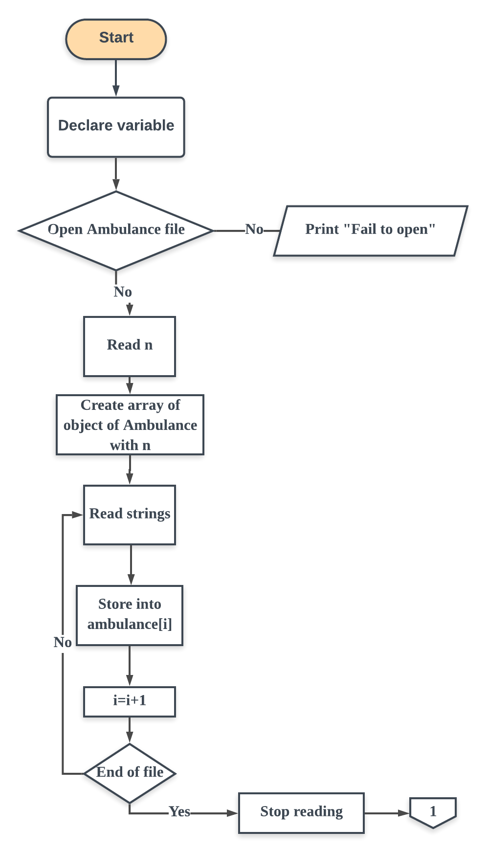

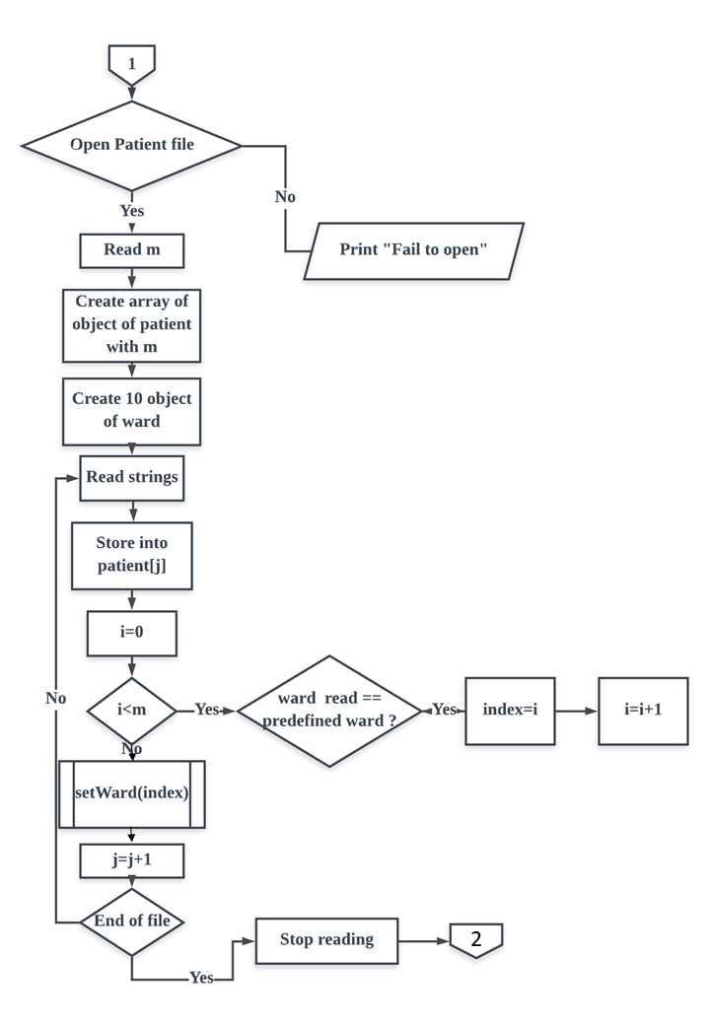

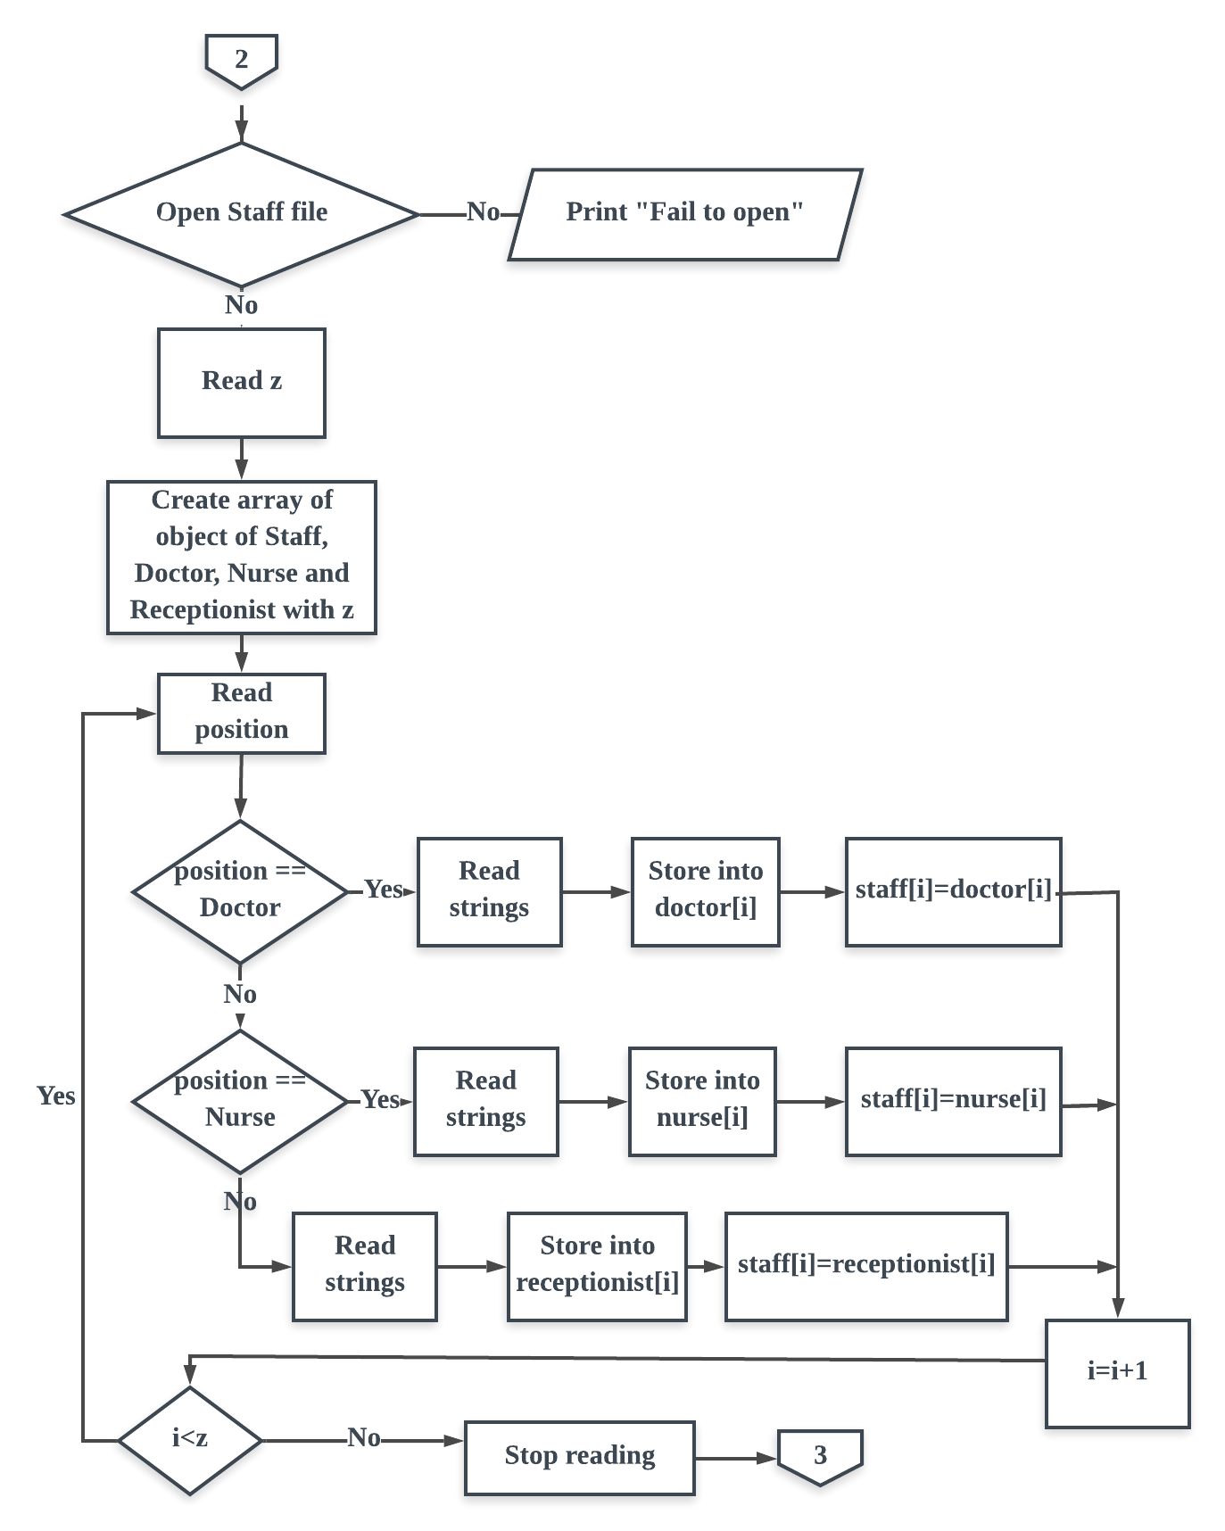

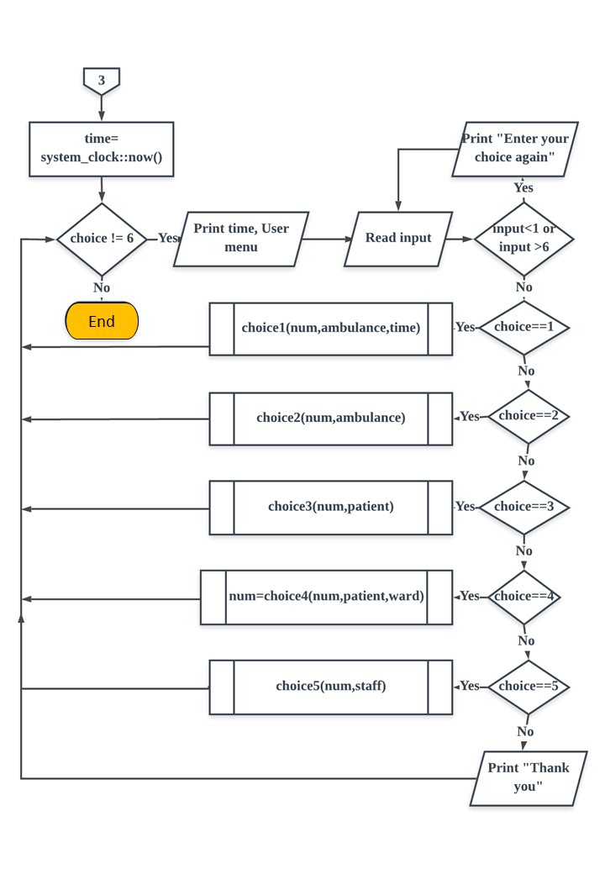

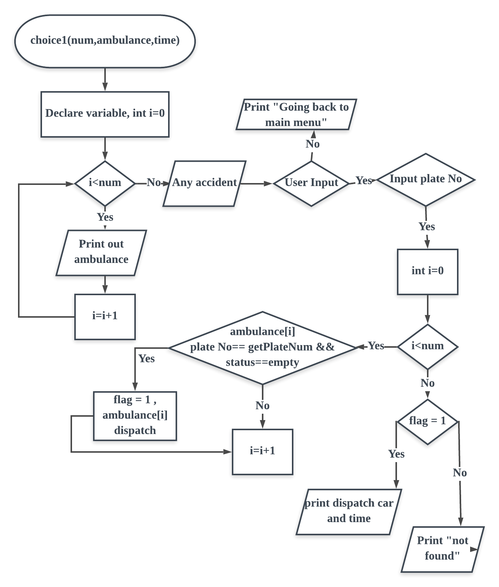

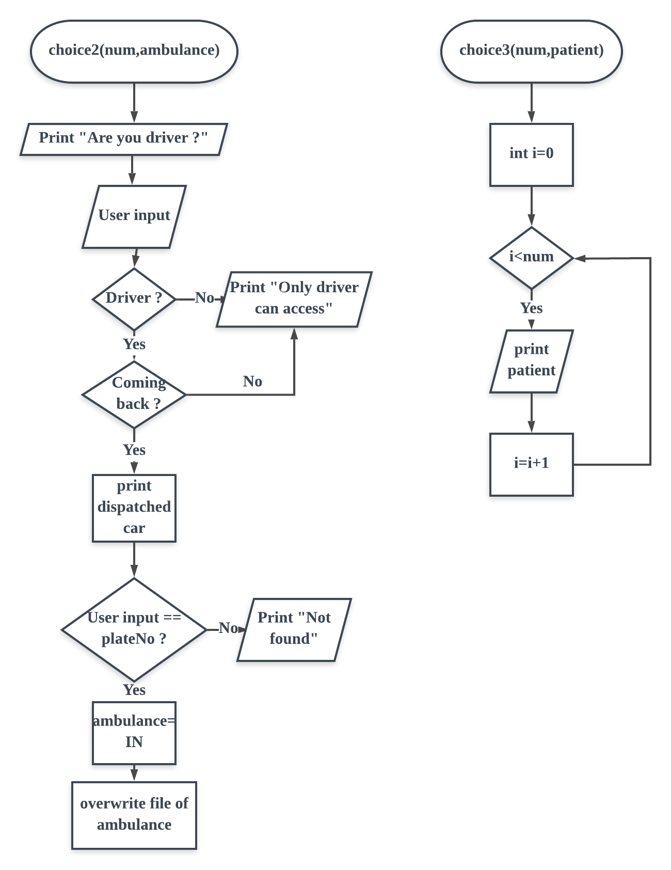

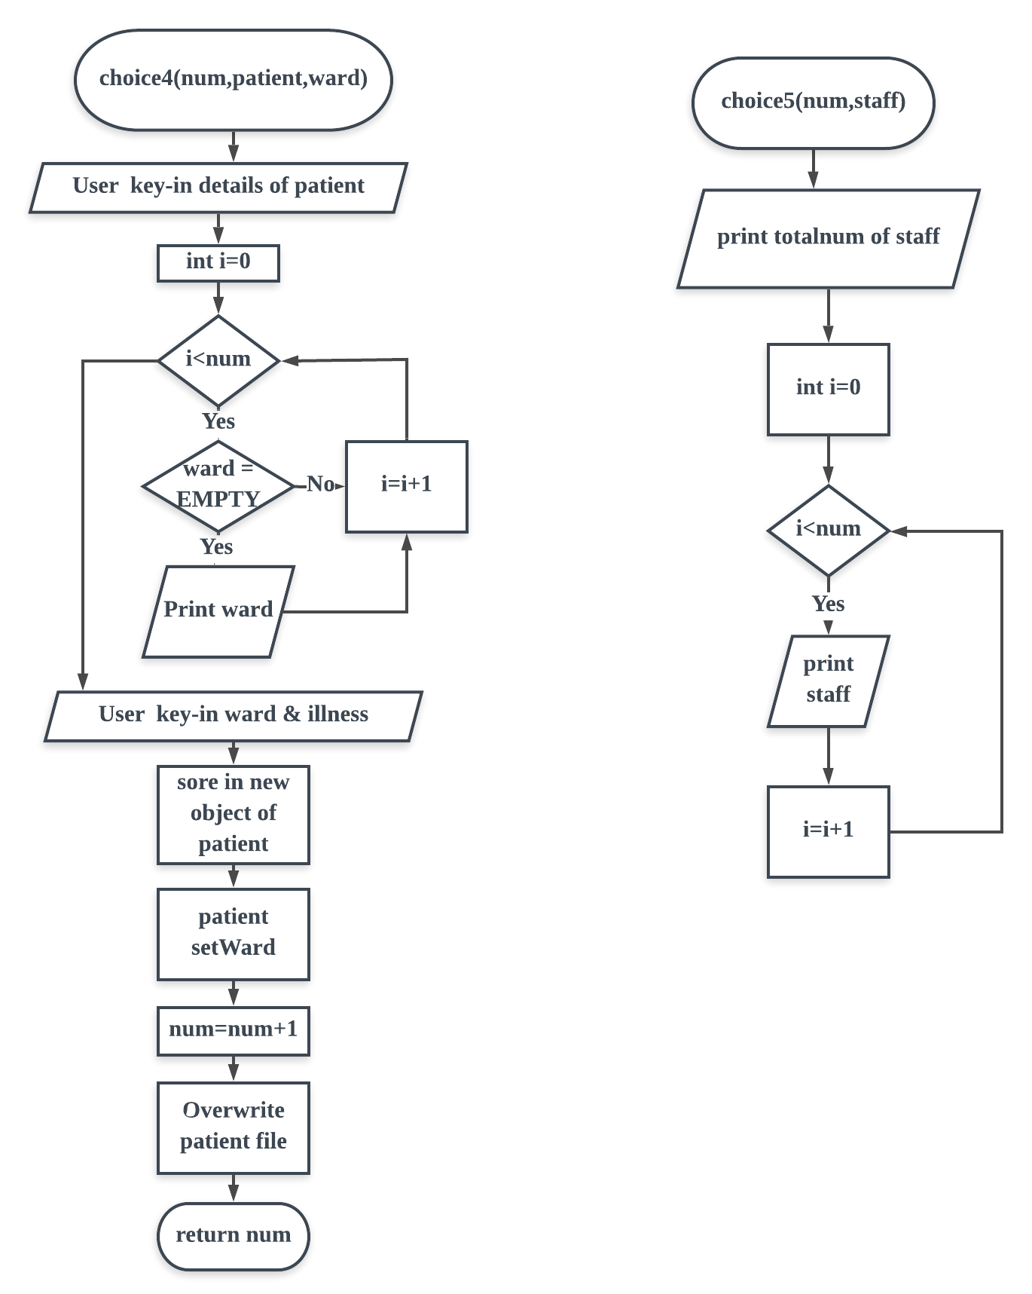

Reference

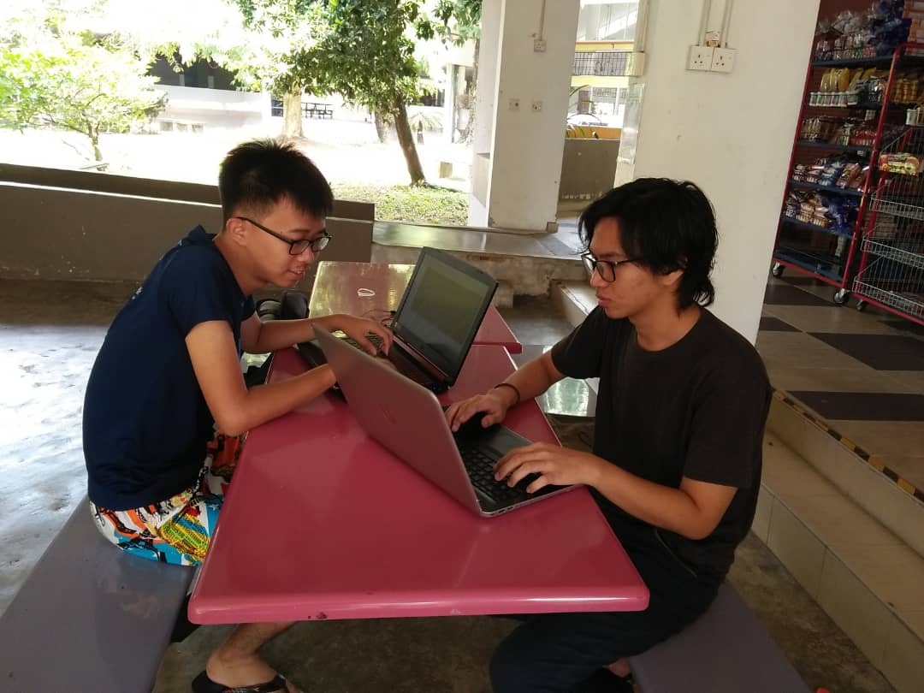

Picture of the group discussion on 3/5/2019

